|  |  |
| --- | --- |
| **Logo - Club Logo copy**  Breakfast Chatter  2016 | C:\Users\arasmussen\Downloads\images.jpg |

##### The Weekly Bulletin of Rotary Club of Kathmandu Mid-Town Celebrating 26 Years of Rotary

##### April is the month of Maternal and Child Health

# Weekly Meetings and Programmes:

|  |  |  |
| --- | --- | --- |
| Date | Speaker | Program/Topics of Presentation |
| 8 April | General Gaurav Shumsher Jung Bahadur Rana | “Nepal Army – my experience” |
| 1 April |  | Club Assembly |
|  |  |  |

|  |  |  |
| --- | --- | --- |
| Club News | | |
|  |  |  |

|  |  |  |  |  |
| --- | --- | --- | --- | --- |
| Your generous contributions to The Rotary Foundation are essential to securing and growing Rotary programs throughout the world. We recognize donors to express our gratitude for your commitment, offering individual and club recognition as well as naming opportunities that enable you to honor a friend or family member with a named or endowed gift. | | | Roop JyotiDuring the meeting FCP CP Roop was recognized for his new status of Arch Klumph | You become and Arch Klumph Trustees Circle member when your cumulative donations reach $250,000.  Recognition includes an induction ceremony at the Rotary International headquarters in Evanston, Illinois, USA, and your picture and biography in the Arch Klumph Society interactive gallery:  <https://www.rotary.org/myrotary/en/take-action/give/recognition> |
|  |  |

|  |  |
| --- | --- |
| Our club’s treasure Shyam Raj Thapaliya  Managing Director for Osho World Travel Nepal received the top agent award from Turkish Airlines for 2015  C:\Users\arasmussen\AppData\Local\Microsoft\Windows\INetCache\Content.Outlook\CBTFF60Q\IMG_3585.jpg | The Spouse Club is organising a Picnic on 9 April 2016 at a fantastic location - said to be a winery at the outskirts Kathmandu valley.  It might be opportune to encourage this event.  For those who were not present at the last meeting to sign up there will be a sign up sheet this Friday too.  The cost is Rs. 1500 per person.  Thank you in advance for your kind support.  The idea of establishingPataleban Vineyard Resortcame up with the influence from winery resorts in Japan. The company was registered in 2006 in Nepal affiliated to NICHIBI KAIKAN of Tokyo, Japan. The objective of the company is to develop eco-tourism, horticulture and organic farming.    The Resort site lies 16 km west of Kathmandu city at an altitude of 1600m. It covers an area of 2 hector facing north west at Chisapani Village, Baadbhanjyang VDC. 5, Kathmandu, Nepal. It is surrounded by a community forest known as Pataleban, have great views of sunset, the Himalayan range of Langtang, Ganesh, Manaslu, Annapurna and the Valley of Dhading. |

|  |
| --- |
| Rotary Quote of the Week |

Canada announces $40 million in funding to end polio in Pakistan. Thank you to Canada for their continued leadership and commitment. Together we can improve kids' health and create a polio-free world.<http://on.rotary.org/1M9MUf6>

|  |  |
| --- | --- |
|  |  |

# Rotary International News

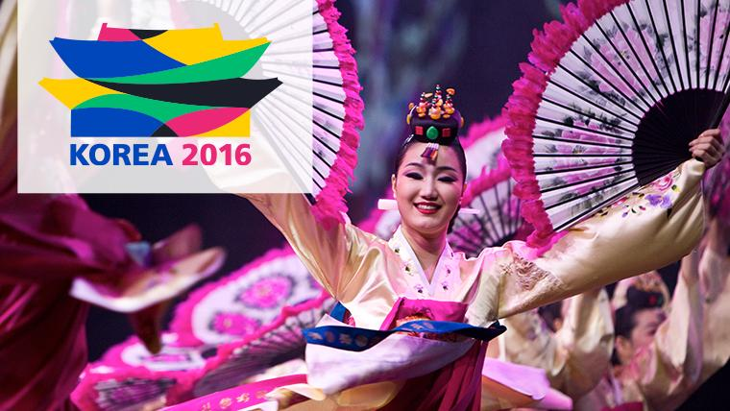**Register for the International Convention in Korea**

### **Connect with thought leaders**

Hear from [exceptional speakers](http://www.riconvention.org/en/seoul/speakers) including RI President K.R. Ravindran and other Rotary senior leaders, who will educate and inspire you.

**31 March 2016:** Preregistration discount ends  
**30 April 2016:** Registration/ticket cancellation deadline  
**1 June 2016:** Online registration ends; deadline for cancellations due to visa denial.

# A WAVE OF COMPASSION

From the[*April 2016 issue*](https://www.rotary.org/myrotary/en/node/228186)ofThe Rotarian

What Kerstin Jeska-Thorwart remembers is the silence. No birds chirping, no dogs barking, no car engines revving. Nothing. “I’ve never heard such a silence before, and never since,” she says. “I knew something must have happened.”

It was 9:35 the morning after Christmas 2004, and in Sri Lanka, it was a Poya Day, a Buddhist public holiday held every full moon. Jeska-Thorwart, a lawyer from Germany, was on vacation in Hikkaduwa, on the island’s southwestern coast. Any other morning of her holiday she and her husband would have been on the beach, but today they stayed back at their vacation home, up a small hill about a half-mile from the water’s edge, to clean and prepare for guests.

After a few minutes, sound returned, as though it had been switched on. Now she heard people running, crying. She went down the main road to see what had happened. She saw people in swimming suits, shoeless, covered in blood.

They told her there was a big wave.

The tsunami, as she later learned, was caused when an earthquake with the estimated force of 23,000 atomic bombs rattled the floor of the Indian Ocean. The seabed rose 10 feet, displacing 7 cubic miles of water. A wall of water, in some places up to 100 feet high, slammed into countries throughout Southeast Asia and as far away as Africa. All told, more than 230,000 people died in 14 countries, and 1.7 million were left homeless. More than half of the dead were in Indonesia, followed by Sri Lanka, where 35,000 people were killed.

https://www.rotary.org/myrotary/en/news-media/wave-compassion

### Calendar:

10-15 April — [Council on Legislation](https://www.rotary.org/myrotary/en/exchange-ideas/events/council-legislation)

15 April — Deadline to report activities to earn a Presidential Citation for [Interact clubs](https://www.rotary.org/myrotary/en/news-media/office-president/presidential-citation-interact-clubs)

*30 A*pril — Registration/ticket cancellation deadline for [Rotary International Convention](http://www.riconvention.org/)

### Please update your ‘My Rotary’ Account

First go to www.rotary.org.

Then **click on My Rotary**. And then **Click on Sign In/Register**.

If you are a first time user, click on **Create account.**

Fill in the Account registration information **and click on Continue.**

You will be informed that an e-mail has been sent to you.

Check your email for the address you provided in the step above. You will receive a message from Rotary. Click on the blue link in the mail to finalize the process.

# A Thought for the Day:

Man's mind, once stretched by a new idea, never regains its original dimensions.

Oliver Wendell Holmes (1809-1894)

### Nepali holidays in April

|  |  |  |
| --- | --- | --- |
| 13 Apr | Wed | Happy Nepali New Year |
| 15 Apr | Fri | Ram Nawami. Ram Navami falls on the ninth day of the Hindu lunar month (thus named Chaitra Masa Suklapaksha Navami). Rama Nawami is a Hindu festival, celebrating the birth of the god Rama to King Dasharatha and Queen Kausalya in Ayodhya. Rama, the seventh avatar of Vishnu, is one of the oldest avatars of Lord Vishnu having a human form. |
| 23 Apr | Sat | Loktantra Diwas (Democracy Day) |

## NB: Send any information/photos that may be of interest to the Club or Rotarians in general to

## BC Editor: Anja M. Rasmussen, email: anjamrasmussen@gmail.com

#### **District : 3292** We**b:** www.rotarymidtown.org.np **Club Id : 26776**

#### Facebook: <https://www.facebook.com/RotaryClubOfKathmanduMidtown>

Venue: Fridays at 7:30AM, Hotel de l'Annapurna, Kathmandu, NEPAL